|  |  |
| --- | --- |
| cetlogo ***CHEMICAL ENGINEERING TRANSACTIONS***  ***VOL. 96, 2022*** | A publication of  aidiclogo_grande |
| The Italian Association  of Chemical Engineering  Online at www.cetjournal.it |
| Guest Editors: David Bogle, Flavio Manenti, Piero Salatino  Copyright © 2022, AIDIC Servizi S.r.l. **ISBN** 978-88-95608-95-2; **ISSN** 2283-9216 | |

The Impact of Marine Bacteria (from Saldanha Bay) on the Performance of an Air-Cathode Microbial Fuel Cell

Meaghan van der Velden, Mpumelelo Thomas Matsena\*, Evans Martin Nkhalambayausi Chirwa

Water Utilisation and Environmental Engineering Division, Department of Chemical Engineering, University of Pretoria, Pretoria 0002, South Africa.

mpumelelo.matsena@gmail.com

Investigating the performance of microbial fuel cells (MFCs) and the bacterial cultures used within them is an important part of the search for renewable, sustainable energy solutions that can tackle the Earth’s growing energy crisis. Three marine sediment samples taken from Saldanha Bay (South Africa) were combined with a glucose substrate to investigate the performance of halophilic bacteria in an air-cathode MFC. The sample taken from the Site 3 (Langebaan Beach) produced the highest maximum power density of 0.036 mW m-3 and the lowest volume-specific internal resistance of 416 Ω m3 at 40 °C. The performance of this sample was optimized at 30 °C and pH 9, where a low volume-specific internal resistance of 287 Ω m3 and a maximum power density of 0.046 mW m-3 was achieved. The results suggested the presence of both acidophilic and alkaliphilic mesophiles and established their ability to produce electrical energy. This work successfully confirmed the electrogenic behavior of halophilic bacteria from Saldanha Bay and the potential for large-scale industrial application after further in-depth study.

* 1. Introduction

Majority of the world’s electricity production is derived from non-renewable sources of energy. As populations continue to grow and pollution levels rise, alternative clean and sustainable solutions need to be implemented in order to save the world from the growing energy crisis. Fuel cells are potential clean alternatives which convert chemical energy into electrical energy. Microbial fuel cells in particular have attracted recent attention (Chin et al., 2021; Medina Mori et al., 2022).

MFCs use active microorganisms as bio-catalysts to break down organic matter/waste and produce bio-electricity. This dual purpose advantage and the averted need for added enzymes, makes them more economical, sustainable and desirable solutions compared to other fuel cells. MFC investigations to date produce limited levels of output power (Najafpour, 2015). Therefore, investigating new microbial species, economical setups and operating conditions for better MFC performance is crucial to enable the industrial application of this technology.

There are three main MFC configurations namely dual-chamber, single-chamber and stacked (Najafpour, 2015). All offer various advantages, however, the single-chamber air-cathode MFC can be viewed as the most efficient (Gadkari et al., 2020) since the lack of a secondary chamber results in lower internal resistance and higher proton flux making them ideal for industrial use. An air-cathode MFC consists of three main components — an anode, cathode and proton exchange membrane (PEM). The design and materials of which all impact the performance of the MFC.

The anode attachment of electrogens directly affects MFC performance provided direct electron transfer mechanisms are utilized (Matsena et al., 2020). Carbon materials are commonly used owing to their economical availability and simple manipulation.

Halophilic bacteria are extremophiles which thrive under super saline conditions (> 1M NaCl) and are commonly found in marine environments. Research has shown that utilizing electrogenic halophiles under super saline operating conditions can broaden the scope of industrial MFC applications and enhance MFC performance owing to the enriched electrolyte conductivity (del Olmo, 2016; Shrestha et al., 2018). Furthermore, physical conditions, such as temperature and pH, to which these microbes are exposed have shown direct effects on cellular activity and MFC performance. Research has indicated that these conditions are microbe specific. The problem is determining the optimal conditions for MFC performance relative to the utilized microbes.

The present investigation aimed to evaluate and optimize the performance of an air-cathode MFC which utilized marine bacteria collected from Saldanha Bay, South Africa. The project objectives were to confirm the electrogenic potential of the collected samples, identify the best performing sediment sample and subsequent optimal operating conditions.

In this work, the best performing sediment sample from Saldanha Bay was identified and the optimal pH and temperature conditions were determined to enhance MFC performance. System performance was evaluated on measured output potential, maximum power output and internal resistance.

* 1. Materials and Methods
     1. Microbial samples and Growth Medium

2.1.1 Microbial samples

Sediment samples were collected from Saldanha Bay (Cape Town, South Africa) at three site locations: Site 1 (Saldanha Bay), Site 2 (Saldanha North Beach) and Site 3 (Langebaan Beach). The samples were stored in a refrigerator at 4 °C for further use.

2.1.2 Basal mineral media (BMM)

BMM growth medium was prepared according to (Matsena et al., 2020) and was sterilized before use in an autoclave at 121 °C at 115 kg cm-2 for 15 minutes.

* + 1. Anode chamber inoculation

Bacterial cultures were cultured anaerobically, in sterilized Erlenmeyer flasks containing 2.0 g of sample and 300 mL of sterilized Luria-Battani broth (LB), for 2 days at (30 ± 1 °C) in a shaker incubator operating at 150 rpm. The cultured cells were centrifuged at 4 °C and 6000 rpm for 15 minutes after incubation. The supernatant was disposed and the pellets were washed three times in a 0.85 % sterile solution of NaCl.

Experiments were carried out with an anode working volume of 320 mL consisting of the harvested cells, glucose (5.0 g L-1) and BMM. The anode chamber was purged with N2 gas for 2 minutes and tightly sealed to prevent any air from entering prior to each experiment.

* + 1. Air-Cathode MFC Set-Up

2.3.1 Set-Up

The MFC configuration can be observed in Figure 1a.

**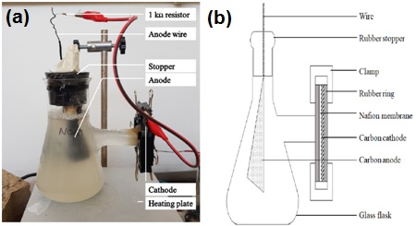**

Figure 1: (a) Overall physical configuration; (b) and detailed cross-section schematic showing cathode-membrane layout for an air-cathode Microbial Fuel Cell (MFC).

The anode chamber had an effective working volume of 320 mL and was separated from the cathode by a Nafion 117 (Fuel Cell Store, USA) PEM membrane as demonstrated in Figure 1b. The anode chamber temperature was adjusted using a heating plate and batch operation was conducted at a fixed external resistance of 1 kW.

2.3.2 Cathode Preparation

A phase inverted polyvinylidenefluoride (PVDF) cathode was constructed by binding PVDF paste to a 35 × 40 mm carbon cloth current collector (Aerontec Pty. Ltd., Cape Town, South Africa) according to the method presented by (Yang et al., 2014) (Figure 2a).

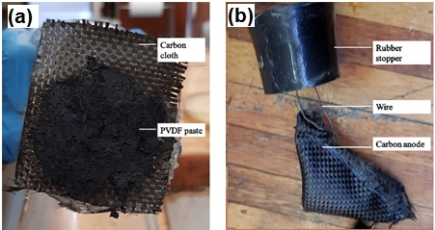

Figure 2: (a) Phase inverted polyvinylidenefluoride (PVDF) carbon cloth cathode; (b) Folded carbon cloth anode containing granules of activated carbon.

2.3.3 Anode Preparation

The anode (Figure 2b) was constructed from 49 cm2 of carbon cloth which was folded and sewn to hold 7.0 g of granulated activated carbon (GAC) with an average particle size range between 0.60 mm and 1.1 mm.

* + 1. Output voltage measurement

Voltage output was monitored using an acquisition data system connected to a Uni-T UT61A multimeter and UT61 software (Uni-Trend Technology Limited, Hong Kong).

* + 1. Performance analysis

Polarization curves were constructed by measuring voltage across variable external resistance (2.7 Ω — 1.2 MΩ) once the MFC had reached a maximum voltage output during batch operation at 1.0 kΩ external resistance. Current density was determined using Eq(1):

|  |  |
| --- | --- |
| I = Um/(Rext∙V), | (1) |

where *I* denotes current density (mA m-3), *Um* is the measure output potential (mV), *V* is the working chamber volume (m3) and *Rext* is the external resistance (Ω).

Power density was calculated according to Eq(2):

|  |  |
| --- | --- |
| P = (I∙Um)/1000 | (2) |

where P is power density (mW m-3).

The volume-specific internal resistance (Ω m3) was determined using a straight line model fitted to the polarization curves.

* 1. Results and Discussion
     1. Performance of different microbial samples from Saldanha Bay in an air-cathode MFC

Microbial samples from three sites in Saldanha Bay: Site 1 (Saldanha Bay), Site 2 (Saldanha North Beach) and Site 3 (Langebaan Beach), were tested to determine which sample displayed the best MFC performance. Each microbial sample was labelled according to collection site. Figure 3a and Figure 3b display the polarization and power density curves obtained by the samples.

**(b)**

**(a)**

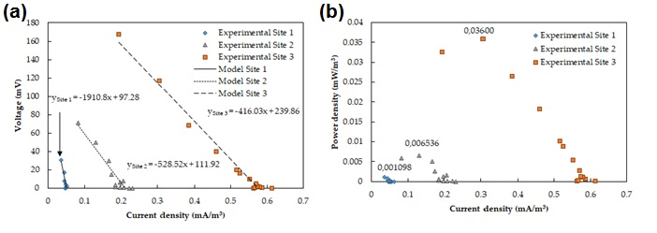

Figure 3: (a) Polarization curves (b) and power density curves of an air-cathode Microbial Fuel Cell (MFC) utilising marine sediment samples taken at three different sites in Saldanha Bay (South Africa) namely: Site 1 (Saldanha Bay), Site 2 (Saldanha North Beach and Site 3 (Langebaan Beach).

An inversely linear relationship was observed between voltage and current density (Figure 3a). Our study showed that Site 1 had the highest volume-specific internal resistance of 1911 Ω m3 compared with 528.5 Ω m3 and 416.0 Ω m3 from Site 2 and Site 3 respectively.

Results showed that Site 3 obtained the highest power density of 0.036 mW m-3 while Site 1 and Site 2 obtained lower values of 0.0011 mW m-3 and 0.0065 mW m-3 respectively (Figure 3b).

The study confirmed the electrogenic potential of the microbe’s present in the sediment samples. The sample collected from Site 3 was clearly the best performing microbial sample with the lowest level of internal resistance and highest power density output.

* + 1. pH effects on an air-cathode MFC

The pH investigation was conducted at 40 °C using the best performing sediment sample (Site 3). Figure 4 below displays the results obtained.

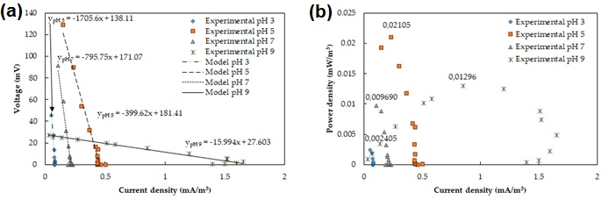

Figure 4: (a) Polarization curves (b) and power density curves of an air-cathode Microbial Fuel Cell (MFC) utilising a marine sediment sample taken at Langebaan Beach, Saldanha Bay (South Africa) at various levels of operating pH.

The polarization curve (Figure 4a) indicated significant ohmic polarization in the MFC. Operating at pH 9 appeared to offer the lowest level of volume-specific internal resistance of 15.99 Ω m3, while pH 3 offered the highest at 1706 Ω m3. Interestingly, the volume-specific internal resistance was lower at pH 5 (399.6 Ω m3) compared with pH 7 (795.8 Ω m3).

The results suggested the presence of alkaliphiles (eg*. Geoalkalibacter* spp.(Badalamenti et al., 2013)) because these microorganisms are known to thrive under alkaline pH 9. This explained the low volume-specific internal resistance observed. This theory was further supported by the poor MFC performance and high internal resistance observed at pH 3 where the acidic conditions damaged the alkaliphile cellular proteins and destroyed cell activity.

Likewise, the better results observed at pH 5 compared with pH 7 suggested the presence of acidophiles (eg*. Acidiphilium* sp.(Malki et al., 2020)) which are known to thrive under slightly acidic levels of pH, hence the lower observed internal resistance.

The study showed a maximum power density of 0.021 mW m-3 obtained at pH 5 while lower values of 0.0024 mW m-3, 0.0097 mW m-3 and 0.0130 mW m-3 were obtained at pH 3, 7 and 9 respectively (Figure 4b). The higher power density achieved at pH 5 suggested that the postulated acidophiles were more electrogenic than the alkaliphiles which thrived at pH 9.

Despite the lower power density achieved at pH 9, the experimental results displayed a wider operational range of current densities over which power density was maintained, unlike pH 3, 5 and 7 which displayed a rapid decline in power density over a short current density range. Therefore, pH 9 was considered optimal owing to the sustained level of power density and low volume-specific internal resistance achieved. Optimal pH levels of 6.5 were reported by (Gobalakrishnana and Bhuvaneswari, 2019) and (Jadhav and Ghangrekar, 2009) for actinobacteria. According to (Bailey and Ollis, 1986) methanotropic bacteria thrive between pH levels of 6 and 8, therefore, it was estimated that no methanotropic bacteria were present in the sample since optimal power densities were observed outside of the required range.

* + 1. Temperature effects on an air-cathode MFC

The temperature experiments were conducted using the best performing sediment sample (Site 3) at pH 9 according to results from Section 2.1 and 2.2. Figure 5 displays the polarization and power density curves obtained.

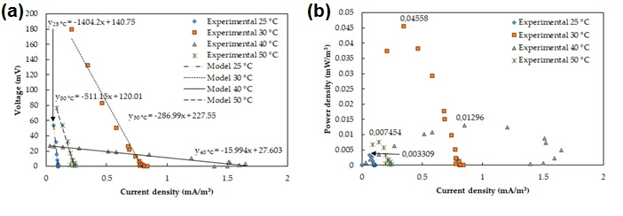

Figure 5: (a) Polarization curves (b) and power density curves for an air-cathode Microbial Fuel Cell (MFC) utilising a marine sediment sample taken at Langebaan Beach, Saldanha Bay (South Africa) at various operating temperatures.

The study showed significant ohmic polarization in the designed MFC (Figure 5a). An operating temperature of 25 °C displayed the highest volume-specific internal resistance of 1404 Ω m3 while lower values of 287.0 Ω m3, 15.99 Ω m3 and 511.2 Ω m3 were observed at 30 °C, 40 °C and 50 °C respectively.

The results suggested the presence of mesophiles owing to the low internal resistance observed between 30 °C and 40 °C. This hypothesis was encouraged by the higher internal resistance observed at 25 °C and 50 °C. At these temperatures mesophiles are outside of their optimal growth rate temperature range and experience cellular damage, which explained the collected results.

Results indicated that a maximum power density of 0.0456 mW m-3 was achieved at 30 °C as compared with the lower amounts of 0.0033 mW m-3, 0.0130 mW m-3 and 0.0075 mW m-3 achieved at 25 °C, 40 °C and 50 °C respectively (Figure 5b). It was noted that a higher power density was sustained over a longer current density range at 30 °C and 40 °C while operating temperatures of 25 °C and 50 °C produced lower levels of power density over a narrow range of current density.

The sustained level of power density achieved at 40 °C was much lower than the amount achieved at 30 °C, despite the wider operational current density range and lower internal resistance observed at the higher temperature. This suggested that the mesophiles thriving at 30 °C, were more electrogenic than those thriving at 40 °C. Chemical reactions are also known to occur at faster rates when exposed to higher temperatures.

Based on results (Figure 5), the optimal MFC operating temperature was 30 °C since higher levels of power density and low levels of internal resistance were achieved. Similar results were reported by (Gobalakrishnana and Bhuvaneswari, 2019) for marine actinobacteria obtained from the Havelock island of the Andamans; nearly 250 mV at 37 °C. And according to (Gobalakrishnana and Bhuvaneswari, 2019), (Larrosa-Guerrero et al., 2010) produced 174.0 mW/m3 at 35 °C for single chamber MFCs with carbon cloth cathodes and several others observed optimal cellulose activity levels and MFC performance at temperatures ranging between 30 and 40 °C (Alam et al., 2004; Kumar et al., 2013; Rathnan and Ambili, 2011).

* 1. Conclusions

MFC technology holds promising potential to help aid in the world’s energy crisis. This investigation has shown that marine bacteria collected from Saldanha Bay (South Africa) are capable of generating bio-electricity. The microbes present at Site 3 (Langebaan Beach) provided the best power density result of 0.03600 mW m-3 and the lowest volume-specific internal resistance of 416 Ω m3. This sample achieved optimized results, while operating at a temperature of 30 °C and pH 9, with a power density of 0.0456 mW m-3 and a volume-specific internal resistance of 287 Ω m3. The sample was hypothesized to contain both alkaliphilic and acidophilic mesophiles which thrive between 30 °C and 40 °C, under slightly acidic (pH 5) and alkaline pH (pH 9) levels respectively. It is recommended that further culture isolation analysis be done to determine the strains of bacteria present within the Site 3 sample, as well as additional larger scale analysis be conducted to determine the industrial suitability of the optimized MFC.

Acknowledgments

The authors would like to thank Alette Devega for assistance during this research.

References

Alam, M.Z., Manchur, M.A., Anwar, M.N., 2004, Isolation, purification, characterization of cellulolytic enzymes produced by the isolate Streptomyces omiyaensis. Pakistan Journal of Biological Sciences, 7, 1647-1653.

Badalamenti, J., Krajmalnik-Brown, R., Torres, C., 2013, Generation of high current densities by pure cultures of anode-respiring Geoalkalibacter spp. under alkaline and saline conditions in microbial electrochemical cells. mBio*,* 4.

Bailey, J.E., Ollis, D.F., 1986, *Biochemical engineering fundamentals*, 2nd ed. McGraw Hill, New York.

del Olmo, O.M., 2016. Microbial Fuel Cells under Extreme Salinity. Civil and Environmnetal Engineering, Rice University, Houston, Texas, pp. 139.

Chin M.Y., Phuang Z.X., Hanafiah M., Zhang Z., Woon K.S., 2021, Exploring the Life Cycle Environmental Performance of Different Microbial Fuel Cell Configurations, Chemical Engineering Transactions, 89, 175-180.

Gadkari, S., Fontmorin, J.M., Yu, E., Sadhukhan, J., 2020, Influence of temperature and other system parameters on microbial fuel cell performance: Numerical and experimental investigation. Chemical Engineering Journal, 388.

Gobalakrishnana, R., Bhuvaneswari, R., 2019, Microbial fuel cells potential of marine actinobacteria Actinoalloteichus sp. MHA15 from the Havelock island of the Andamans, India. Biotechnology Research and Innovation, 3, 144-158.

Jadhav, G.S., Ghangrekar, M.M., 2009, Performance of microbial fuel cell subjected to variation in pH, temperature, external load and substrate concentration. Bioresource Technology, 100, 717-723.

Kumar, R., Lone, S.A., Ali, S., Pattnaik, S., Kumari, N., Kumar, D., et al., 2013, Cellulolytic activity of actinomycetes isolated from Areraj region Bihar. Current Discovery, 2, 92-96.

Larrosa-Guerrero, A., Scott, K., Head, I.M., Mateo, F., Ginesta, A., Godinez, C., 2010, Effect of temperature on the performance of microbial fuel cells. Fuel, 89, 3985-3994.

Malki, M., De Lacey, A., Rodriguez, N., Amils, R., Fernandez, V., 2020, Preferential use of an anode as an electron acceptor by an acidophilic bacterium in the presence of oxygen. Applied and Environmental Microbiology, 74, 4472-4476.

Matsena, M.T., Tichapondwa, S.M., Chirwa, E.M.N., 2020, Synthesis of Biogenic Palladium Nanoparticles Using Citrobacter sp. for Application as Anode Electrocatalyst in a Microbial Fuel Cell. Catalysts, 10.

Medina Mori M., Suarez Alvites H., del Pilar Lopez Padilla R., Castaneda-Olivera C.A., Benites Alfaro E.G., 2022, Alternative Energy by Bioelectrogenesis from the Bacteria Pseudomonas Aeruginosa and Aeromonas Hydrophila, Chemical Engineering Transactions, 93, 145-150.

Najafpour, G.D., 2015, Biochemical Engineering and Biotechnology (2nd Edition), 2nd ed. Elsevier.

Rathnan, R.K., Ambili, M., 2011, Cellulase enzyme production by Streptomyces sp. using fruit waste as substrate. Australian Journal of Basic and Applied Sciences, 5, 1114-1118.

Shrestha, N., Chilkoor, G., Vemuri, B., Rathinam, N., Sani, R., Gadhamshetty, V., 2018, Extremophiles for microbial-electrochemistry applications: A critical review. Bioresource Technology, 255, 318-330.

Yang, W., He, W., Zhang, F., Hickner, M., Logan, B., 2014, Single-Step Fabrication Using a Phase Inversion Method of Poly(vinylidene fluoride) (PVDF) Activated Carbon Air Cathodes for Microbial Fuel Cells. Environmental Science & Technology Letters, 1, 416 - 420.